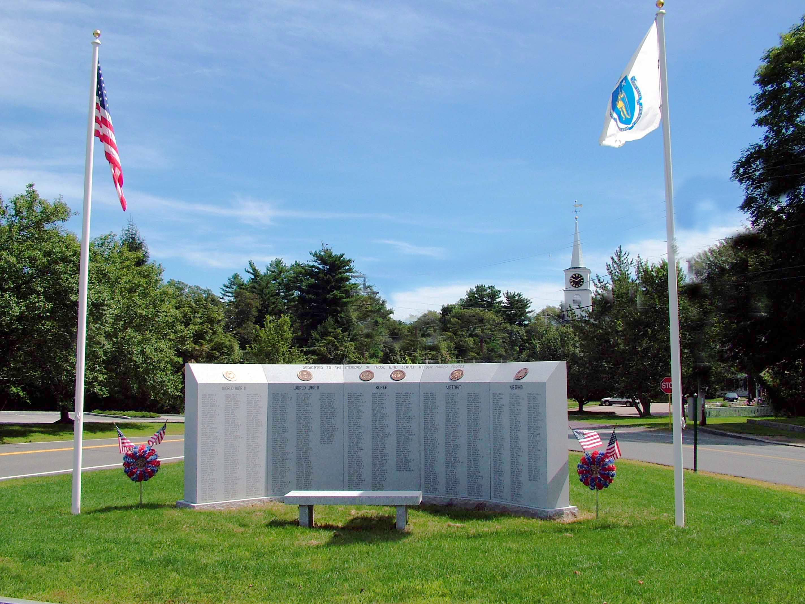

7:00 Open
Call to Order
7:30 Citizen Comments

7:35 Pinning Ceremony for Sergeant Timothy O’Brien

7:45 Ron Mott – Harbormaster Fees

Approval of Minutes
Appointments

Old Business
- Dissolve Committees

- STM Articles & Discussion

New Business
- Road Opening Season Closing Date

- Request from South Shore Dancers to extend Cushing Center hours on New Year’s Eve

- Constable Appointment

Upcoming Meetings
Announcements – National Emergency Alert System
Adjournment
Executive Session – Contracts & Personnel

